LEGO Crane Kit
Glen Bull, Jo Watts, and Moses Kumenya
The goal of this project is to use the parts provided in the Sangala Crane Kit to assemble a LEGO crane. The crane began as photograph that was translated into a mosaic of LEGO tiles using Sangala Mosaic.
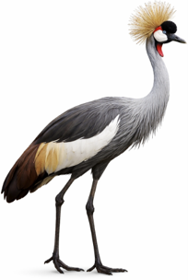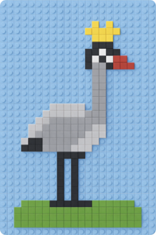
tiles using The digital plan for the mosaic of LEGO tiles was then imported into Sangala Studio and translated into a frame that was used to create a three-dimensional projection of the two-dimensional mosaic. This three-dimensional figure was used to create a 3D-printed crane. The 3D-printed crane (shown on the left below) was then imported into Sangala Blocks and used to design a three-dimensional figure composed of LEGO bricks (shown on the right below).
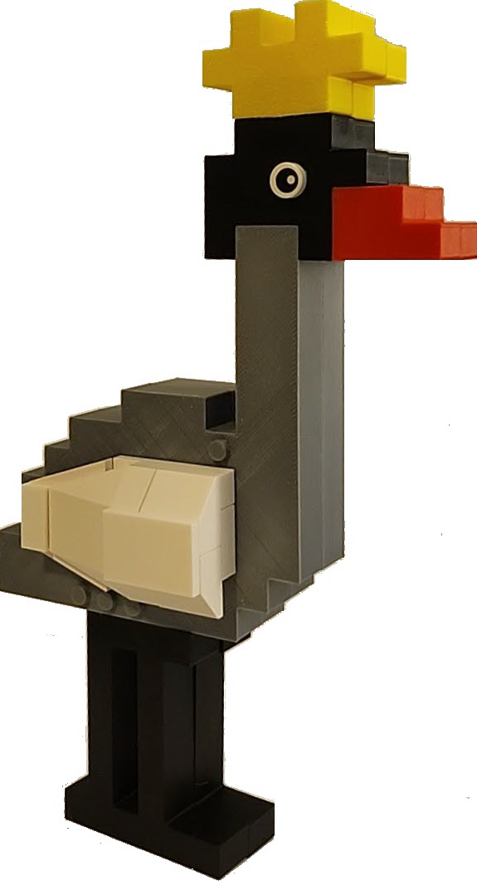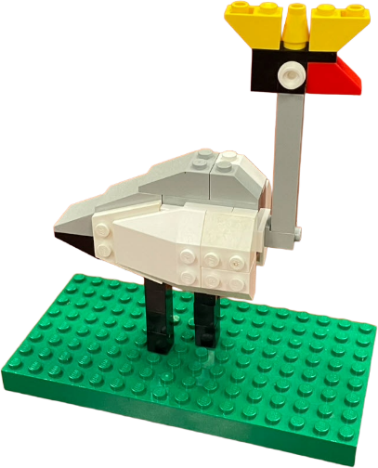
used to design The LEGO bricks in your Sangala Crane Kit are divided into bags containing the parts to assemble different elements of the LEGO crane, including the crown, the head, the body, the wings, and the legs. The completed three-dimensional LEGO figure is placed on a green LEGO baseplate.
The process of using three Computer-Aided Design (CAD) tools, Sangala Mosaic, Sangala Studio, and Sangala Blocks, facilitates the transition from two-dimensional design thinking to three-dimensional design thinking. The goal of this kit is to provide an example of the process that you can use to design your own LEGO kit beginning with a two-dimensional photograph.
1. Head and Crown
Locate the bag of LEGO parts labeled “Head and Crown.”
- Place the Black 1 x 3 Plate on top of the Black 1 x 2 Brick.
- Then add the Red Sloped Brick to create the crane’s bill.
- Place the White 1 x 1 Round Plate to the right of the black brick (and to the left of the red bill) to form the right eye of the crane. Then add a second 1 x 1 round plate to the other side to form the hand eye.
a.  b.  c. 
- Then add the three yellow crown pieces to the top of the head with the cone in the center.
d.  e. 
- The completed head and crown should look like the image on the right (above).
2. Body
Locate the bag of LEGO parts labeled “Head and Crown.”

2.a. Place two dark gray 2 x 4 side-stud bricks side by side to form the core of the body. 2.b. Add a blue 2 x 4 plate to the side studs on the front of the body. 2.c. Then add the second blue 2 x 4 plate to the side studs on the back. 2.d. Add a yellow 2 x 3 plate to the front of the body, over the blue plate. 2.e. Then add the second yellow 2 x 3 plate to the back in the same position. 2.f. This completes the body assembly.
2.a
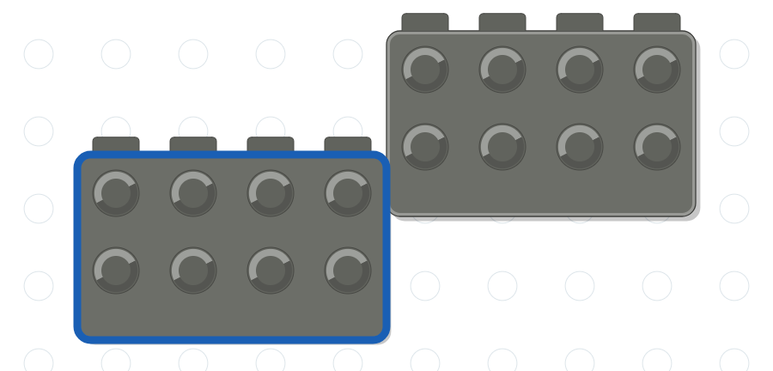

2.b
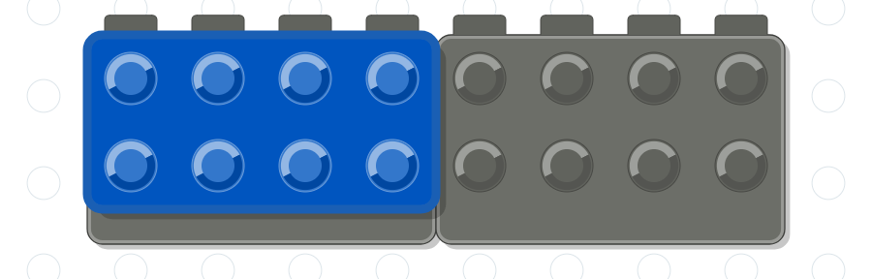

2.c


2.d
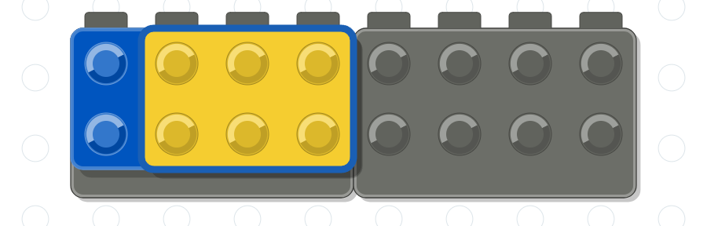

2.e


Section 3. Assemble the Back
3.a. Place the dark gray 2 x 4 brick on top of the body. 3.b. Place a pair of dark gray 3 x 1 slope bricks, one in front of the other, at the tail. 3.c. Add a second pair of 3 x 1 slope bricks one step up the back. 3.d. Add a third pair of 3 x 1 slope bricks to form the next step. 3.e. Finish with a pair of steeper dark gray 2 x 1 slope bricks at the top of the back, where the neck will stand. 3.f. This completes the back assembly.
3.a
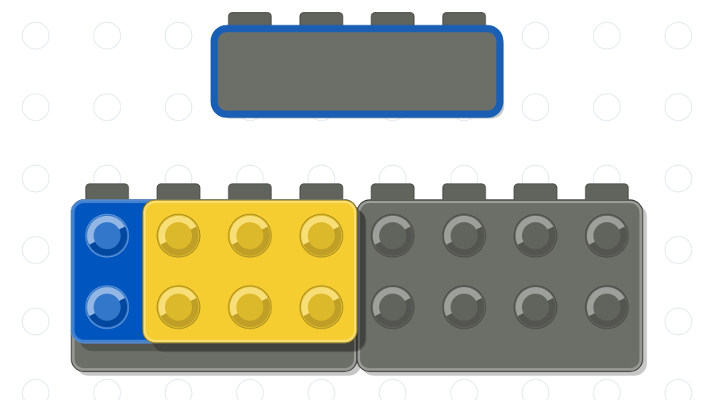

3.b
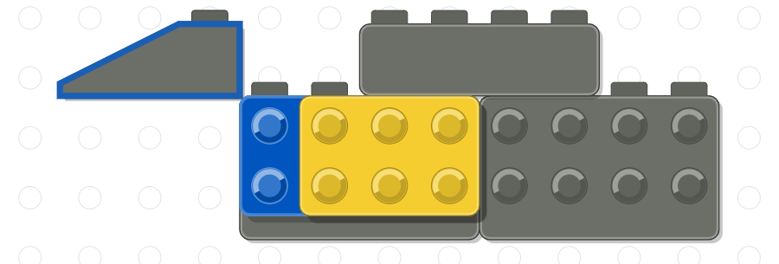

3.c
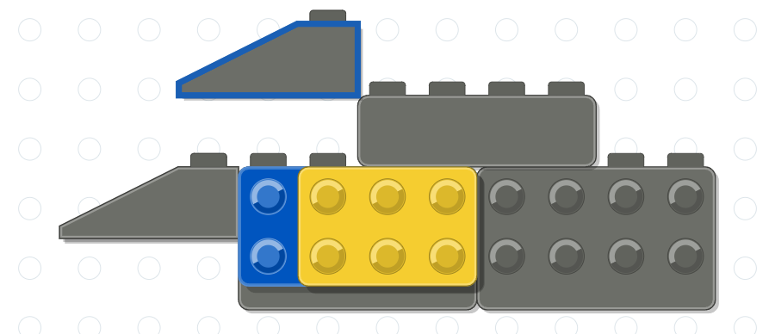

3.d
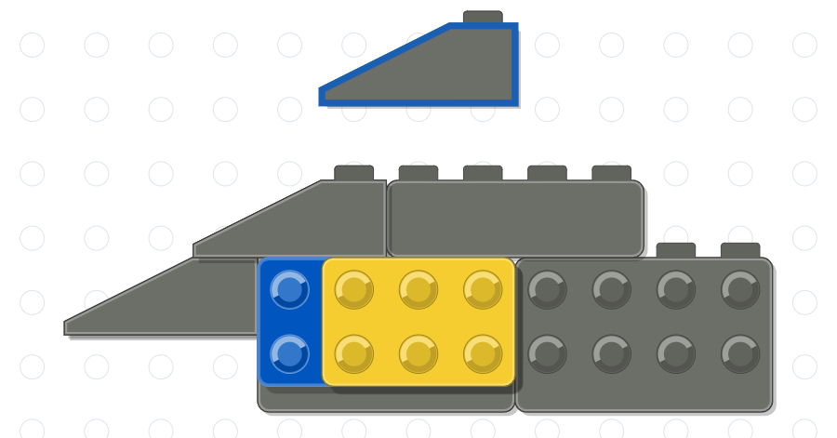

3.e
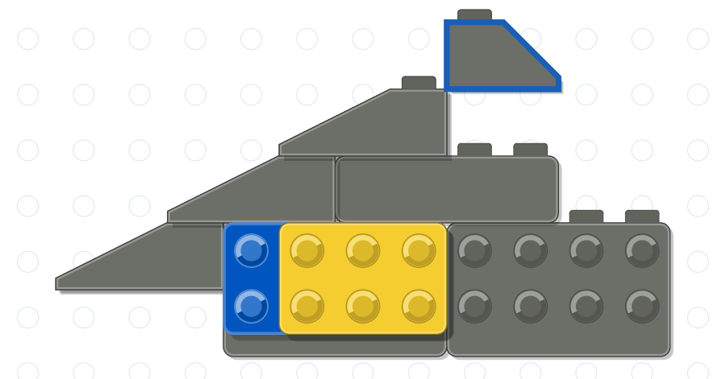

3.f
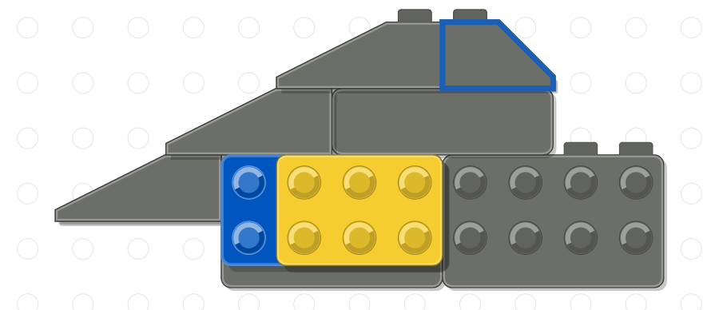

Section 4. Assemble the Wings
4.a. Place a light gray 2 x 2 slope brick at the upper root of the large curved wedge that forms the right wing. 4.b. Add a second 2 x 2 slope brick at the lower root. 4.c. This completes the right wing, with all studs facing forward. 4.d. Assemble the left wing from the same three pieces as a mirror image, with all studs facing away: place one slope brick at the upper root of the wedge. 4.e. Add the second slope brick at the lower root. 4.f. This completes both wings.
4.a
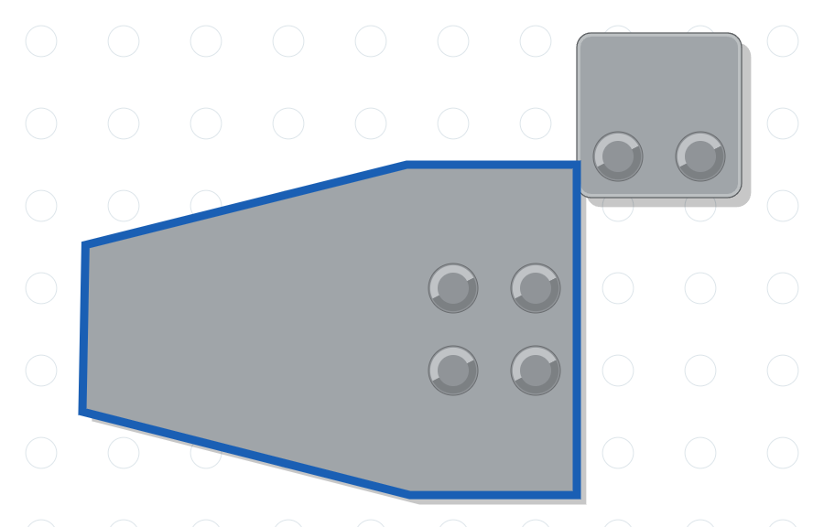

4.b
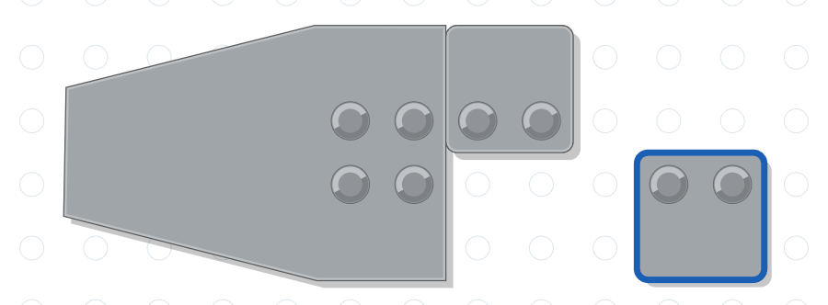

4.c
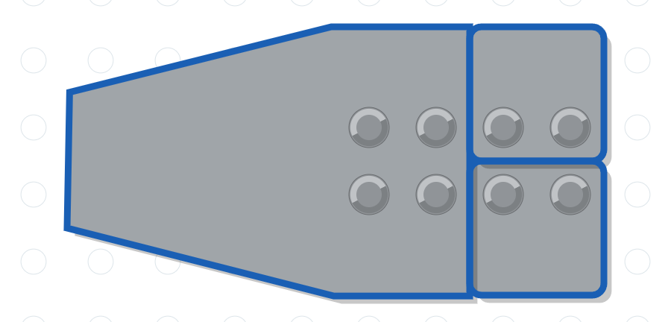

4.d
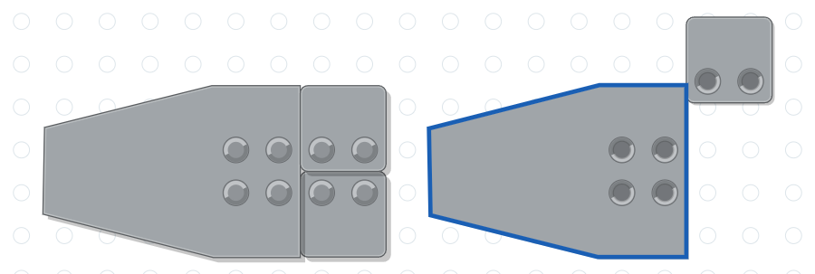

4.e
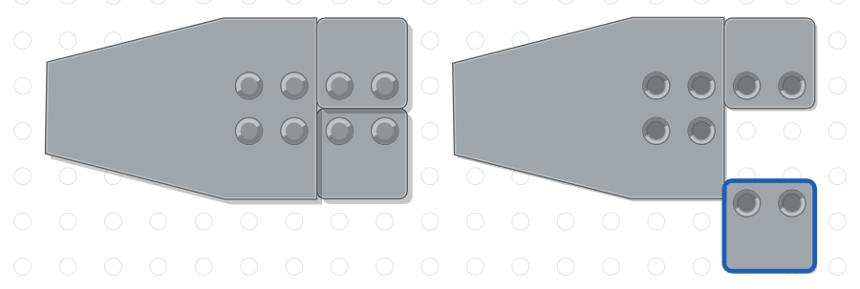

4.f
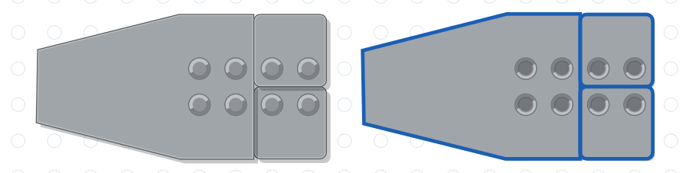

Section 5. Attach the Wings to the Body
5.a. Attach the right wing to the studs of the blue and yellow plates on the front of the body, with the wing sweeping back toward the tail. 5.b. Attach the left wing to the matching plates on the back of the body. 5.c. The wings are now attached.
5.a
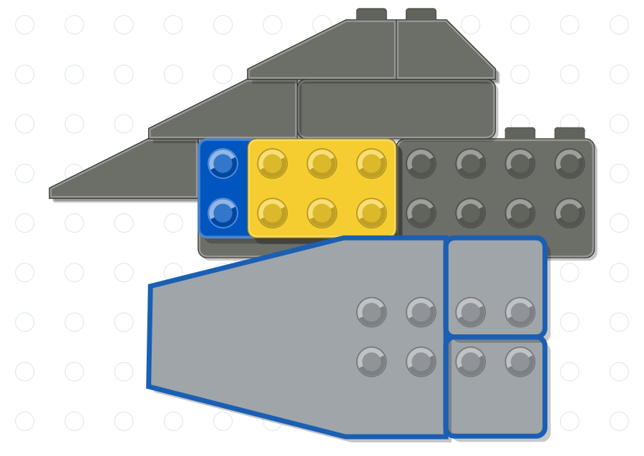

5.b
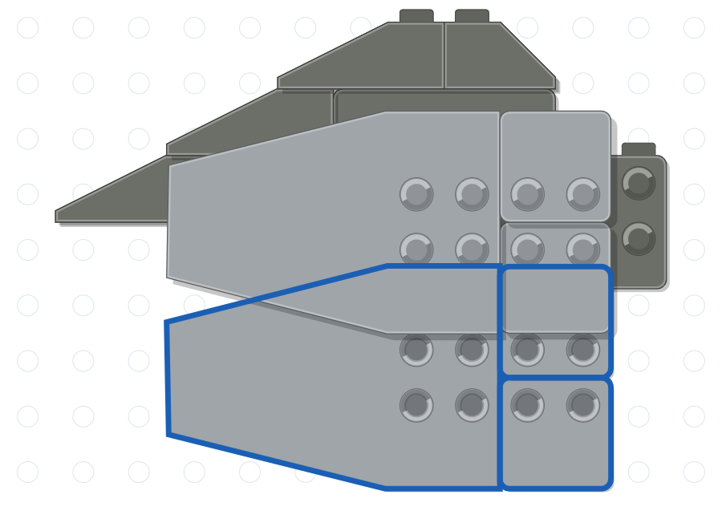

5.c
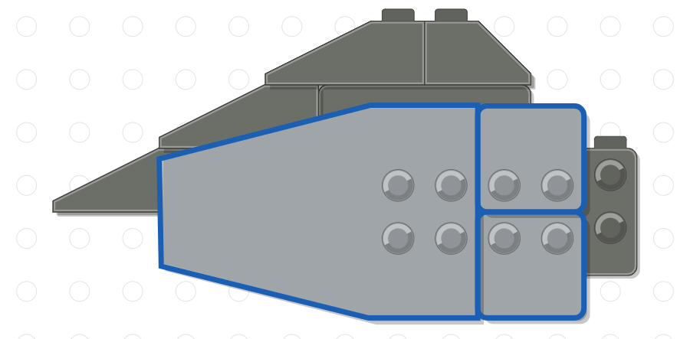

Section 6. Add the Legs to the Body
6.a. Attach a black 1 x 1 x 3 brick beneath the body to form the rear leg. 6.b. Attach the second 1 x 1 x 3 brick beneath the body to form the front leg. 6.c. This completes the legs.
6.a
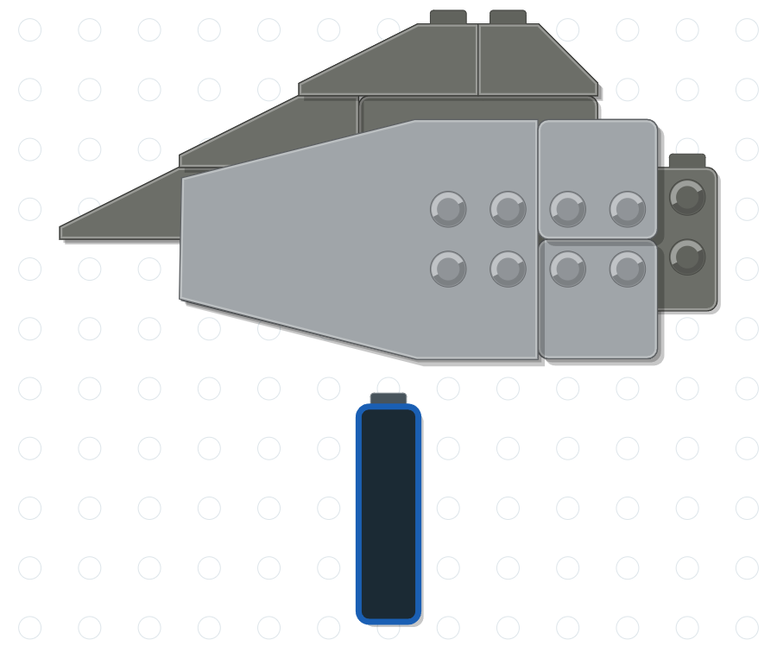

6.b
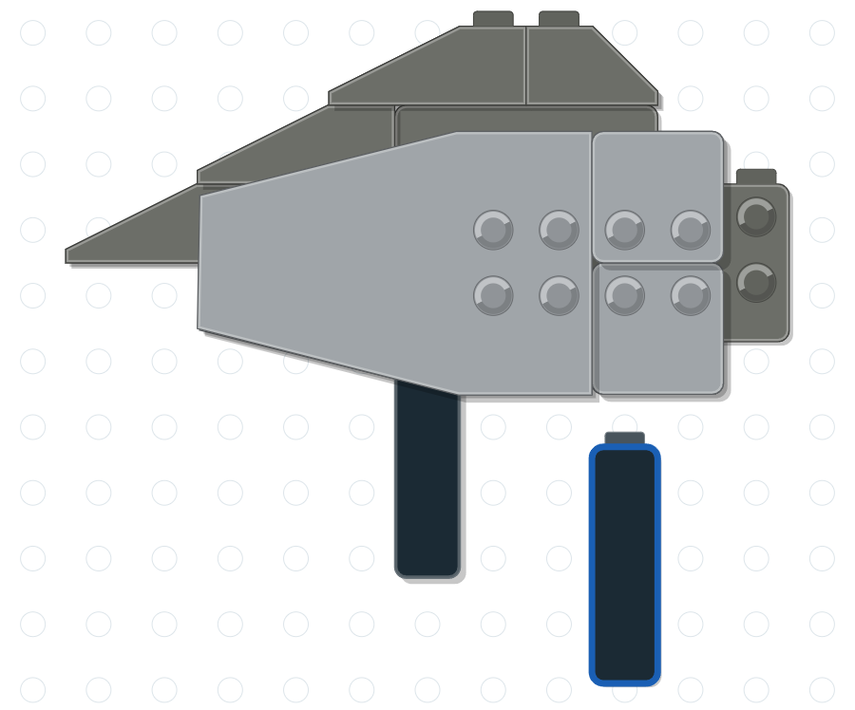

6.c
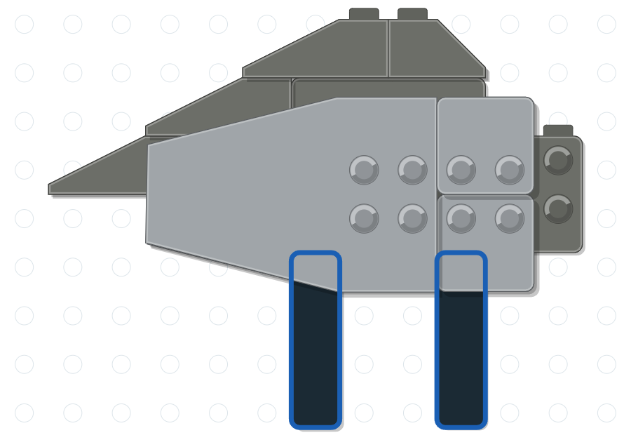

Section 7. Place the Crane on the Baseplate
7.a. Place the green 8 x 16 plate on the work surface and stand the crane on it, with the legs toward the middle of the plate. 7.b. The crane now stands on the baseplate.
7.a
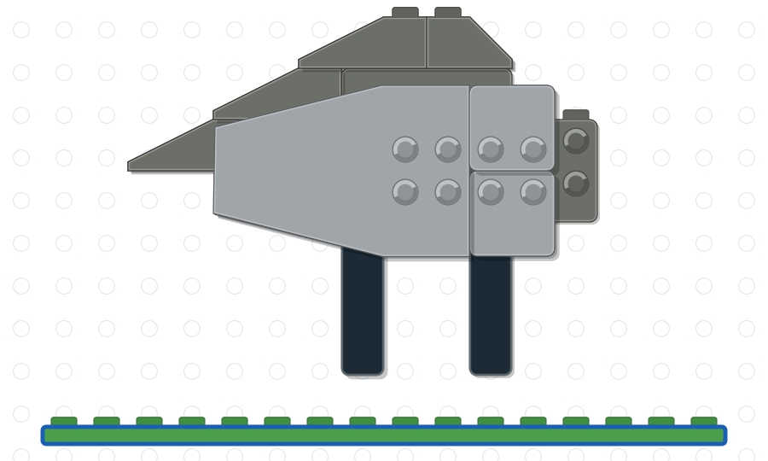

7.b
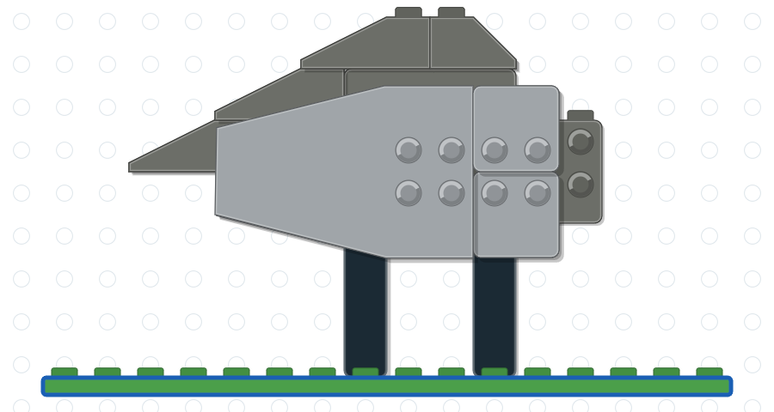

Section 8. Add the Neck
8.a. Attach the light gray 1 x 2 plate with the center stud to the top of the body, in front of the slope bricks of the back. 8.b. Place the tall light gray neck brick on the center stud. 8.c. This completes the neck.
8.a
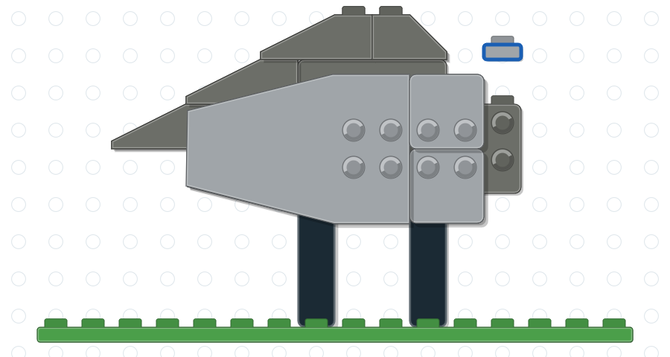

8.b
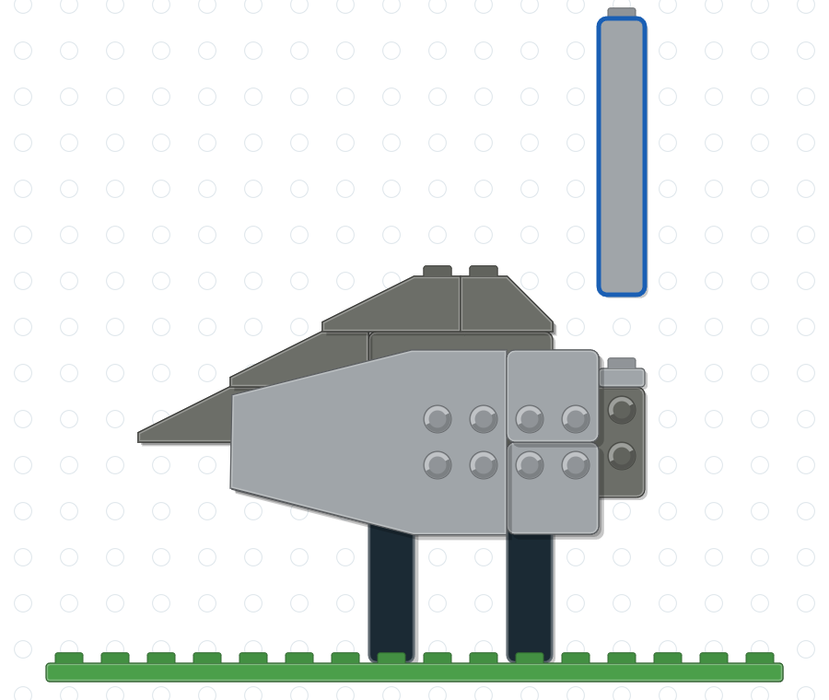

8.c
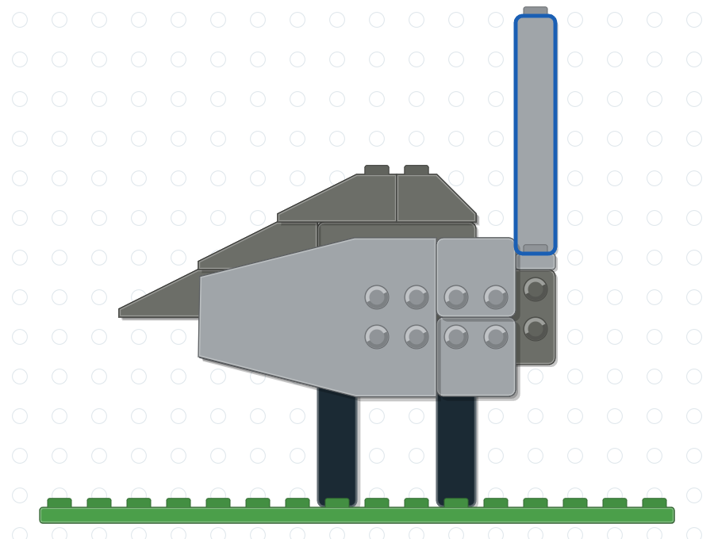

Section 9. Place the Crown and Head on the Neck
9.a. Place the head and crown assembly from Section 1 on top of the neck, with the bill pointing forward. 9.b. The crane is complete.
9.a
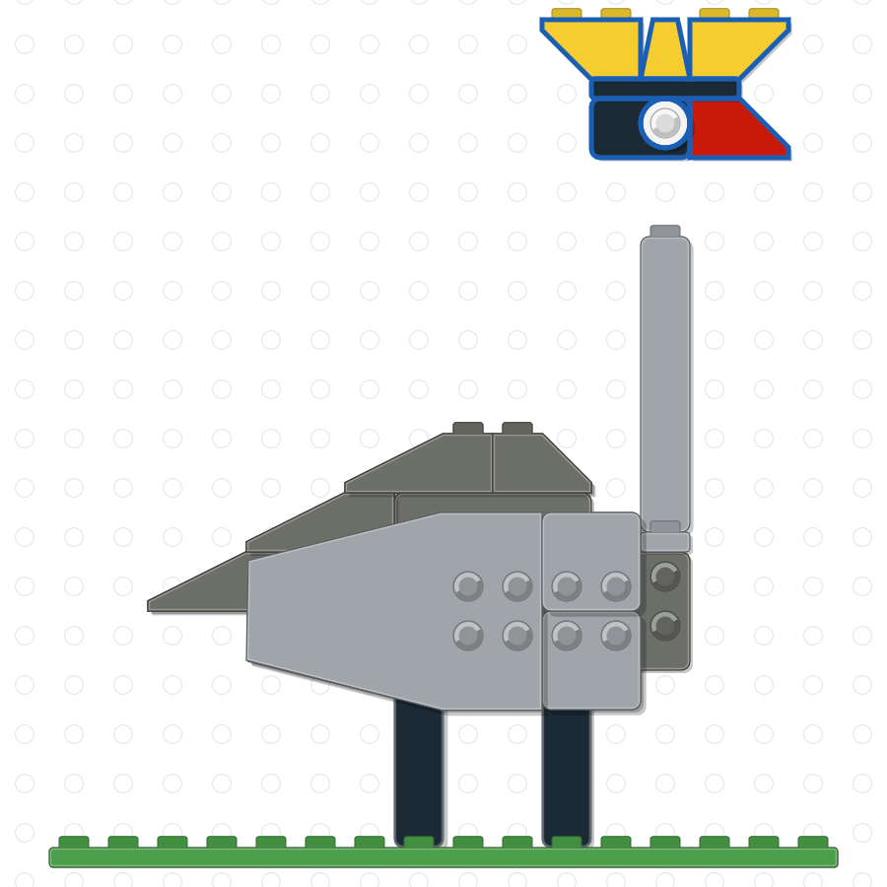

9.b
